Cipher App Description:-

The Transposition Cipher App is a Python program designed for text encryption and decryption using a simple transposition cipher algorithm. It provides an intuitive interface where users can input their plaintext, specify a secret key for encryption or decryption, and view the resulting encrypted or decrypted text.

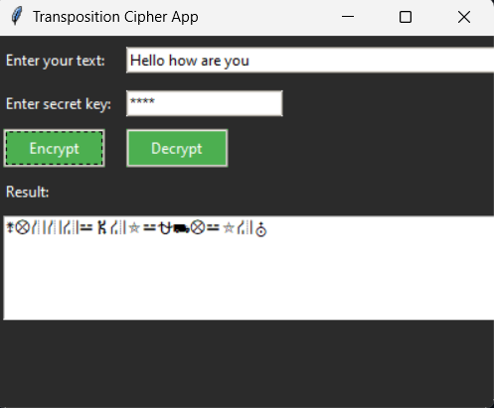

The app utilizes the transposition cipher algorithm, which involves rearranging the characters of the input text based on a specified key. For encryption, the algorithm shifts each character in the plaintext by the key value, while for decryption, it reverses this process by shifting characters in the opposite direction. This approach ensures that the resulting ciphertext is secure and can only be decrypted with the correct key.

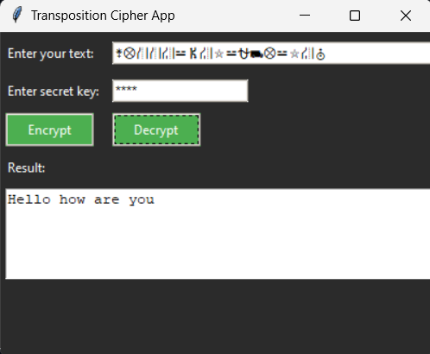

The app's logic involves taking user inputs for plaintext and key, performing the encryption or decryption operation based on the selected action, and displaying the resulting text in the output field. Error handling is implemented to validate the key input and provide informative messages in case of invalid inputs.

Overall, the Transposition Cipher App offers a user-friendly solution for basic text encryption and decryption using the transposition cipher algorithm, providing a practical tool for learning and experimenting with cryptography concepts in a simple and accessible manner.

HOW TO USE:

* Launch the App: Run the Python script to start the application.
* Input Text: Enter the text you want to encrypt or decrypt in the "Enter your text" field.
* Enter Secret Key: Input a secret key in the "Enter secret key" field. This key will be used for encryption or decryption.(This KEY must be same in encrypt/decrypt )
* Encrypt or Decrypt: Click the "Encrypt" button to encrypt the input text using the provided key. Alternatively, click the "Decrypt" button to decrypt the input text.
* View Result: The resulting encrypted or decrypted text will be displayed in the "Result" field.